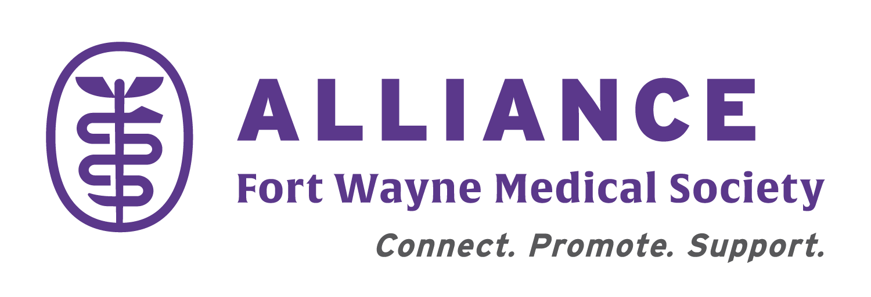
Application for
Community Funding
alliancefw.org

APPLICATIONS ACCEPTED TILL ............September 1st
DECISIONS ANNOUNCED ..Within 1 month of submission

AVAILABLE TO FORT WAYNE COMMUNITY BASED ORGANIZATIONS FOR HEALTH RELATED SUPPORT
Organization Name:

Date of Application .............................. Amount Requested ...............................
Deadline for inclusion(MM/DD/YY) .........N/A.................... Donation or Sponsorship? (circle one)
Are you a non-profit entity? (Y/N) Years in Existence? ............................
Tax Identification Number (TIN) ...........................................................

Brief Description of Organization & Web Site Url if applicable:

How will funds be used?

CONTACT INFORMATION
Name: Job Title: Organization Address:

Phone Number & Email Address

Completed application should be sent to:
FWMS Alliance
ATTN: Treasurer, FWMSA OFFICE (260) 420-2011 FAX (260) 420-3714
709 Clay Street, Suite 101, Email: medalsfw@gmail.com
Fort Wayne, IN 46802

